Nicholas Starace
ID: 4556822
D = 22

Question 1: Propose a Machine Learning Problem
- Identifying tumors in brain images from MRI scans done by individuals comparing healthy brain images against irregular ones can result in significant delays in providing patients with a diagnosis. While the size or location of a tumor is never finite, the scan either has a tumor or no tumor making it a classification problem.
- Potential features:
  - Aggressive or irregular color edges (tumor boundaries)
  - Intensity of pixels (brighter tumor pixels in darker pixel areas of the brain)
  - Texture of tumor regions (heterogeneity)
- Output has two groups: the scan has a tumor (1) or no tumor (0)
- Personally collecting images of MRI brain scans would be difficult due to the lack of access to MRI machines. However, there are plenty of public datasets that contain MRI scans of healthy brains along with sets that contain scans of brains with tumors (https://data.mendeley.com/datasets/c9rt8d6zrf/1).
- Potential challenges might include handling differences between brain thresholds and tumor classification. All brains will have slightly different thresholds between their regions and therefore might result in mislabeled tumors. The second challenge may be in selecting a specific type of tumor that will narrow the dataset and make classification easier for the algorithm to only identify a single type of tumor.

Question 2: Basic Operations
- x looks Gaussian since it fits the shape of a bell curve. Estimating the mean visually from the graph appears to be 2.23 with bin edges being 2.22 and 2.24. The true value is 2.22 leaving an absolute error of 0.01. z looks uniform since it fits the shape of a rectangle.
- Time elapsed to loop over x: 0.0182 seconds
Time elapsed for vectorized addition: 6.94 x 10⁻⁴ seconds
Vectorization addition was about 25 times faster than iteration. Vectorization addition is faster because it uses parallel processing within the CPU to perform computation on each element simultaneously. Iteration sequentially adds 2 to each element, resulting in longer computation.
- Number of elements from Run 1: 333,673
Number of elements from Run 2: 333,080
Each time the program is run, the elements of z are generated from a random distribution and therefore will almost never have identical elements that fit in the range specified. Furthermore, since the distribution of z are uniform, there is an equal likelihood of any number in the range specified to be generated. Given the condition that y can only between 0 and 0.22, the probability is about 0.33 (0.22 / 0.66 = 0.33). As you increase the number of samples, the standard deviation also increase and would lead to larger differences in number of samples in y from run to run.

Question 3: Linear Algebra
- x = 11.4848
y = -1.1818
z = -2.4697
Substitute:
2(11.4848) + 5(1.1818) - 2(-2.4697) = 22
2(11.4848) + 6(1.1818) + 4(-2.4697) = 6
6(11.4848) + 8(1.1818) + 18(-2.4697) = 15

Question 4: Splitting Data
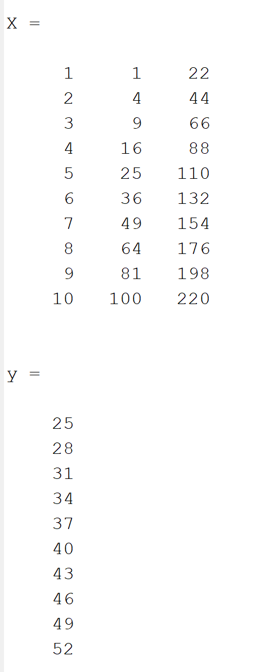

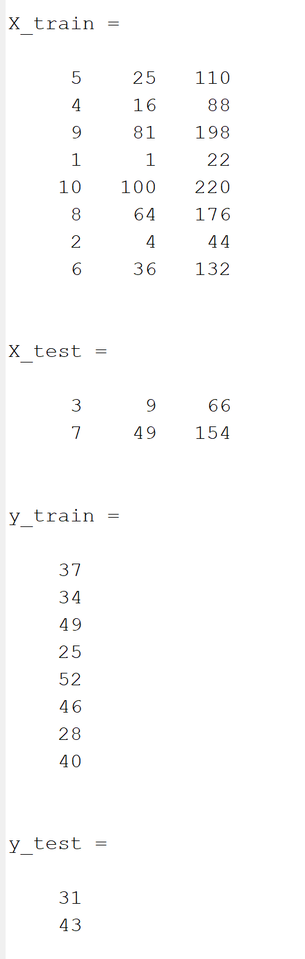
- f

If you ran this code again, you would not get the same split because each row index is chosen at random from a set of permutations.

- New output that is identical each time the code is ran with seed 37:
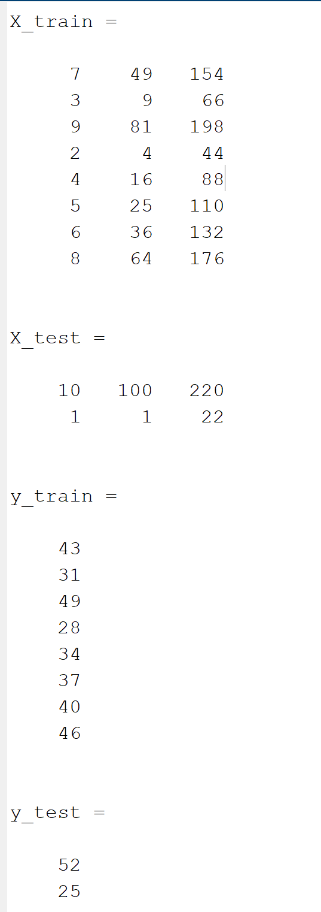

The randomness is now reproducible since I pre-seeded the generator. By calling the rng() function in MATLAB and passing a number to set the seed, a fixed set of random numbers are generated. This technique ensures that while the rows selected are random, the same split will appear every time. Reproducibility is important in machine learning to validate results. If a random set of training or testing data is produced each run, there is no way to repeat and verify the same setup or permutation. Additionally, performance differences may arise from different splits instead of the model and must be reproduced to be investigated.

